Entity Relationship Diagram
User Management Module — KAVERI 3.0
ERD-K3-UM-001 · Version 2.2
Companion to BRD-K3-UM-001 · BRD_User_Management_v4.18
Department of Stamps and Registration, Government of Karnataka
Document ID | ERD-K3-UM-001
Version | 2.2
Status | For review — companion to BRD v4.18
Source BRD | BRD_User_Management_v4.18 (Document ID BRD-K3-UM-001)
Schema | PostgreSQL 14+ · schema `um` · 24 tables · 17 views
Prepared for | Kaveri IT Cell, Department of Stamps and Registration, Government of Karnataka
Last updated | 2026-09-05

1. Purpose and Scope
This document is the physical data model companion to BRD_User_Management_v4.18 (Document ID BRD-K3-UM-001). It presents the User Management schema as four readable sub-diagrams plus a complete entity catalog, and — per the request that produced this revision — every entity's catalog entry ends with a Sample Records section showing realistic example data, not just column definitions.
All tables, columns, keys and views described here are generated directly from the schema actually created by the DDL scripts in the companion DDL folder (00_install_all.sql through 13_sample_transactional_data.sql), and the sample records shown are the exact rows produced by running 12_seed_masters.sql and 13_sample_transactional_data.sql against a live PostgreSQL 16 instance — so this document and the DDL cannot drift apart at the moment of publication.

1.1 How to read the entity catalog
Each entity section (Section 4) has three parts:
- Business purpose — one or two lines tying the table to its BRD functional requirement(s).
- Columns — name, data type, whether it is part of the Primary Key (PK) or a Foreign Key (FK), nullability, the table.column it references (if any), and a description.
- Sample Records — a small "record card" table: one column per illustrative record, one row per attribute, so wide tables (up to 22 columns) stay readable. Master tables (Division, Posts, Roles, Modules, …) show the BRD's own seed rows; transactional tables (users, occupancy, absence, sessions, OTP, audit) show illustrative demo rows built from the BRD's worked examples (SRO Yeshwanthapura / Jayanagar additional-charge example; the DRO Bengaluru handover example; the US-TA-01/02 Temporary Absence example) — clearly not production data.

1.2 Conventions
- PK = Primary Key. FK = Foreign Key (References column names the table.column it points to).
- All timestamps are timestamptz; business dates (joining_date, relieving_date, from_date/to_date, account_end_date) are date, interpreted in Asia/Kolkata (IST) per the BRD's day-boundary rules (FR-UM-058, FR-UM-061, FR-UM-068, FR-UM-080, FR-UM-084).
- No password column exists anywhere in the schema — authentication is OTP + (for DSR/Other Department) biometrics only (FR-UM-009).
- Application Admin is a system-level, deployment-seeded actor: it is deliberately not a row in role_master and not a row in user_master (FR-UM-051). Audit rows it performs carry actor_type = 'APPLICATION_ADMIN' with actor_id NULL.
- remaining_capacity and is_wholly_unoccupied on sanctioned_post are persisted (GENERATED ALWAYS AS ... STORED) so they can never drift from occupied_count — they implement the two distinct vacancy tests of FR-UM-066(a) and FR-UM-066(b) respectively.

2. Diagrams
The full 24-table schema is shown first as a single overview, then as four focused sub-diagrams grouped the same way as the entity catalog in Section 4. PK columns are marked PK, FK columns are marked FK; full column lists and descriptions are in Section 4 — diagrams are for orientation, not exhaustive reference.

2.1 Overview — all 24 tables
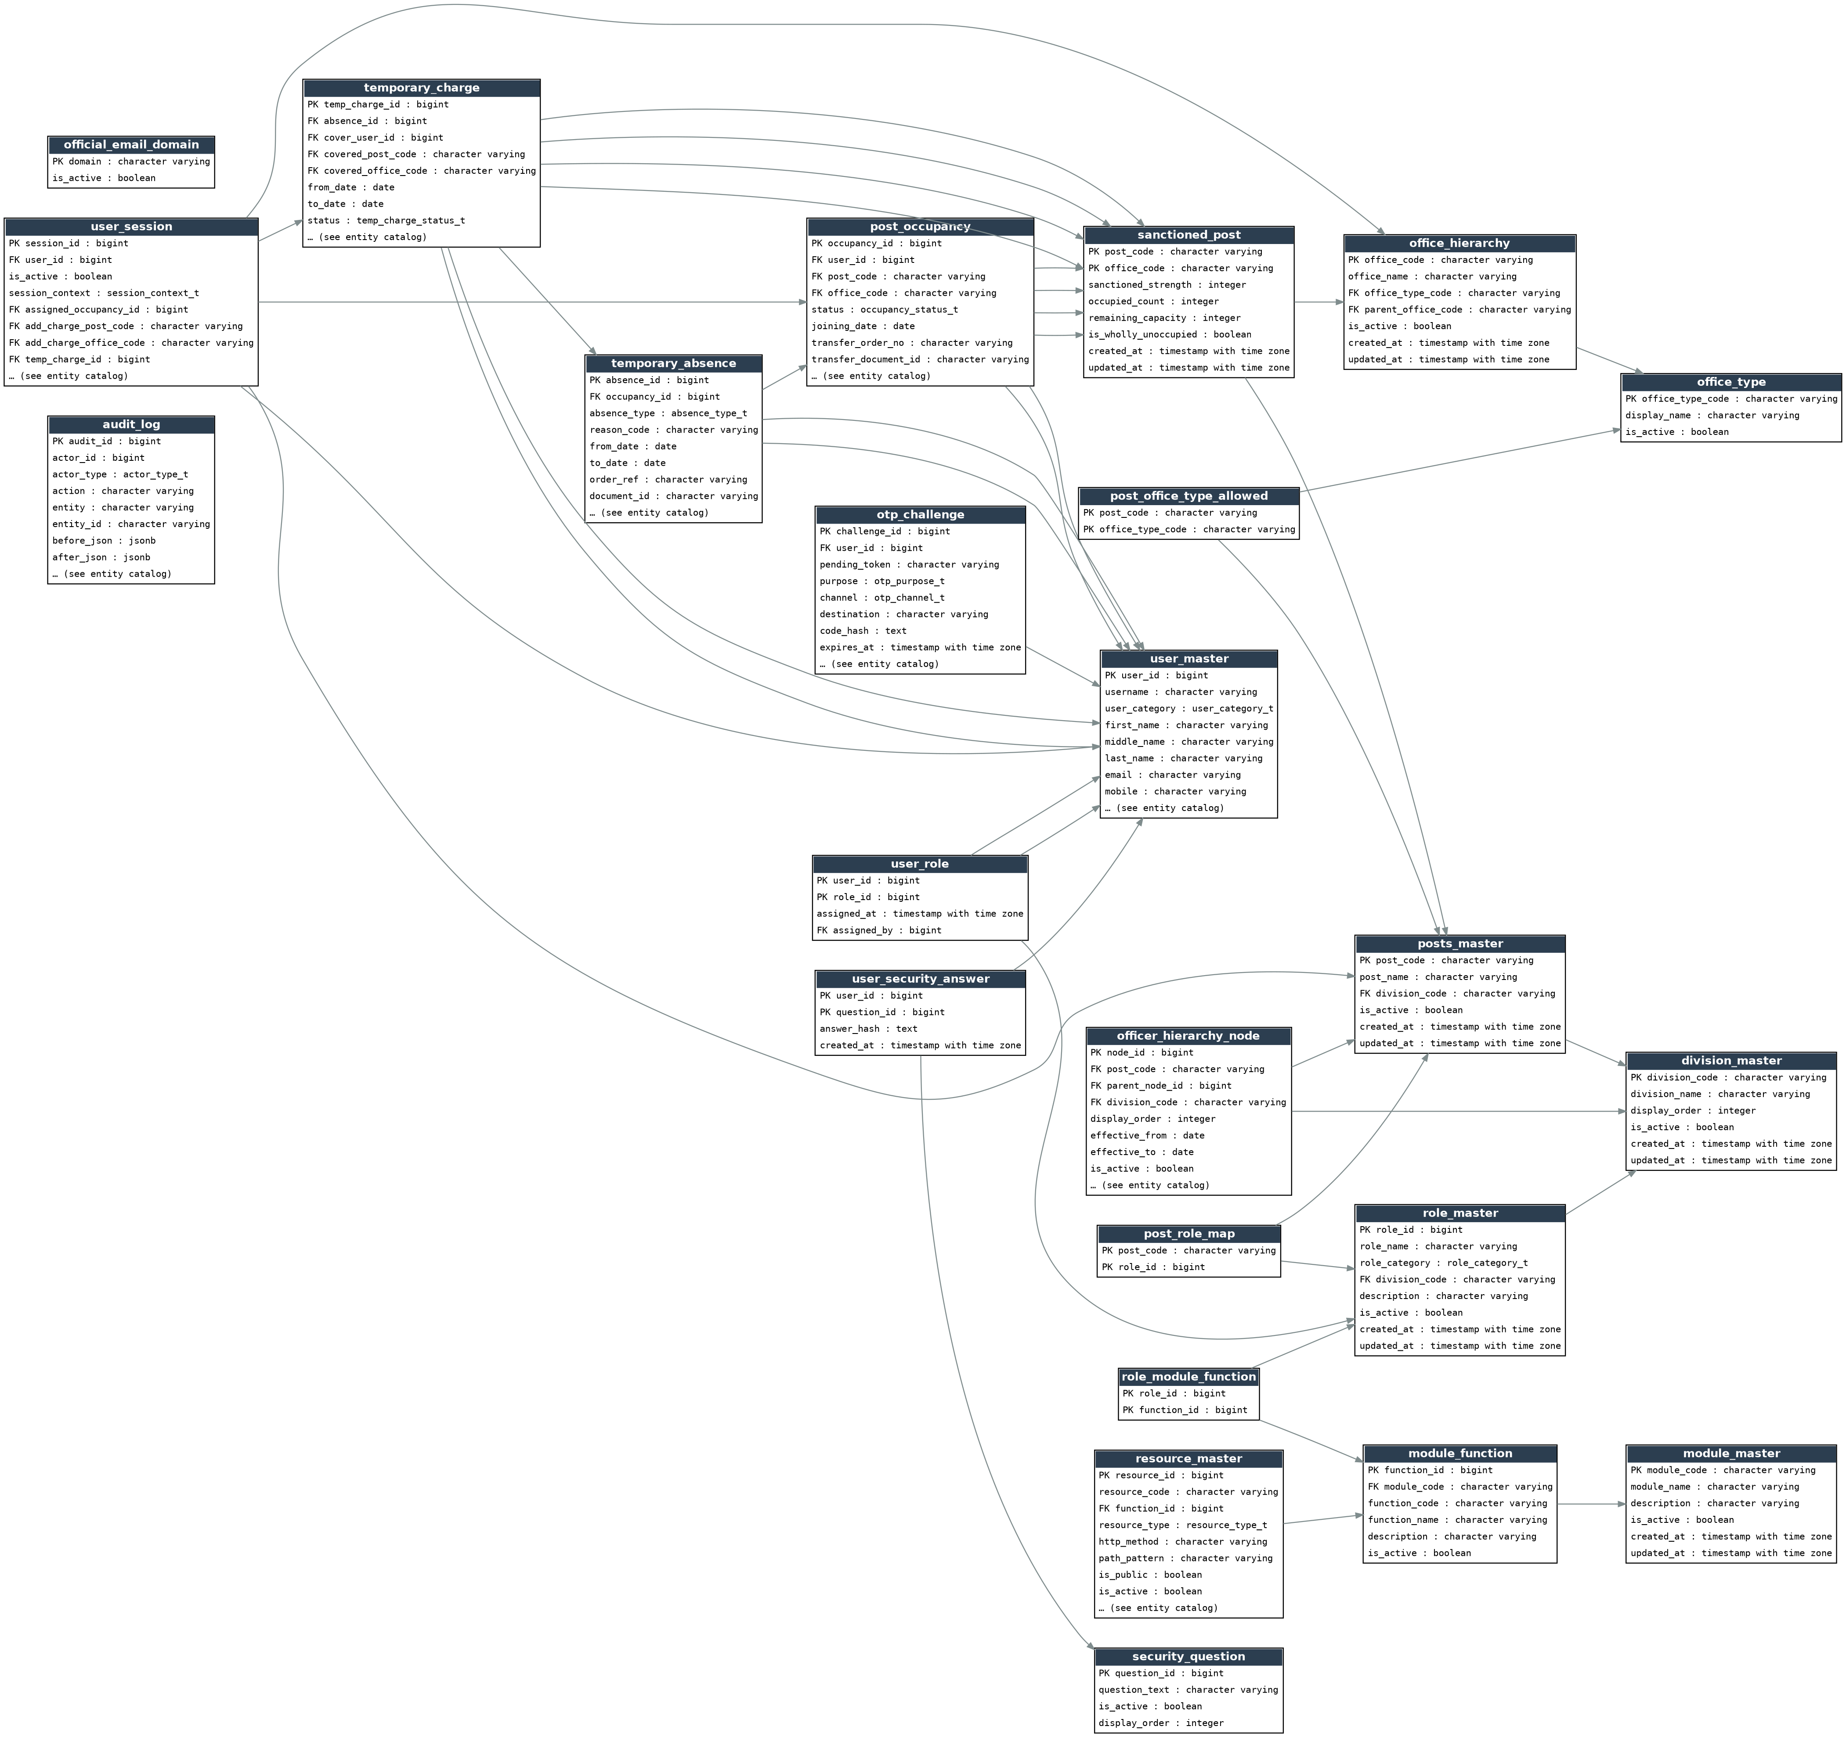
Figure 1 — Full schema overview (um schema, 24 base tables)

2.2 Organisation & Establishment
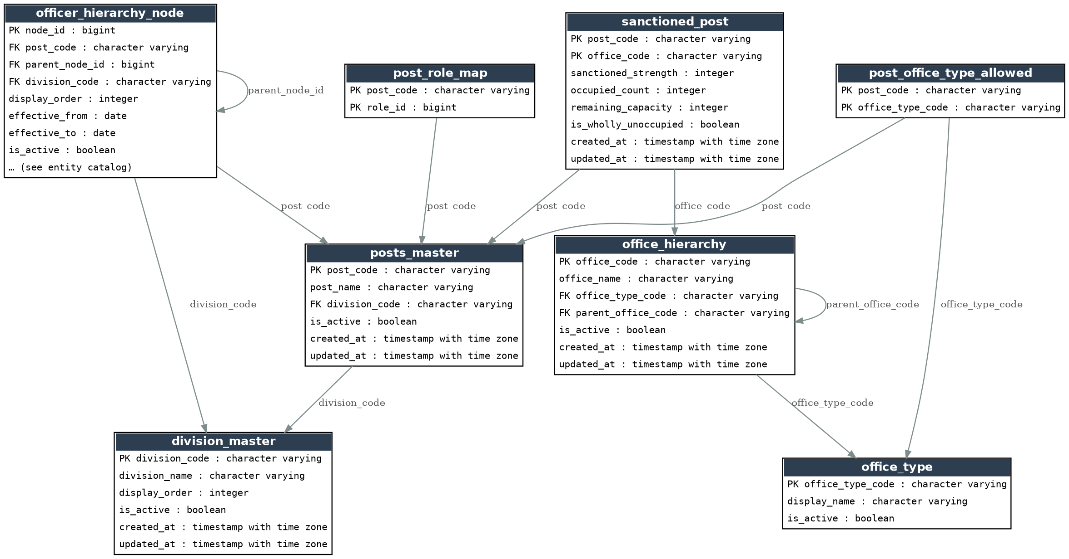
Figure 2 — Division, Office, Posts, Officer Hierarchy, Sanctioned Posts

2.3 Identity & Occupancy
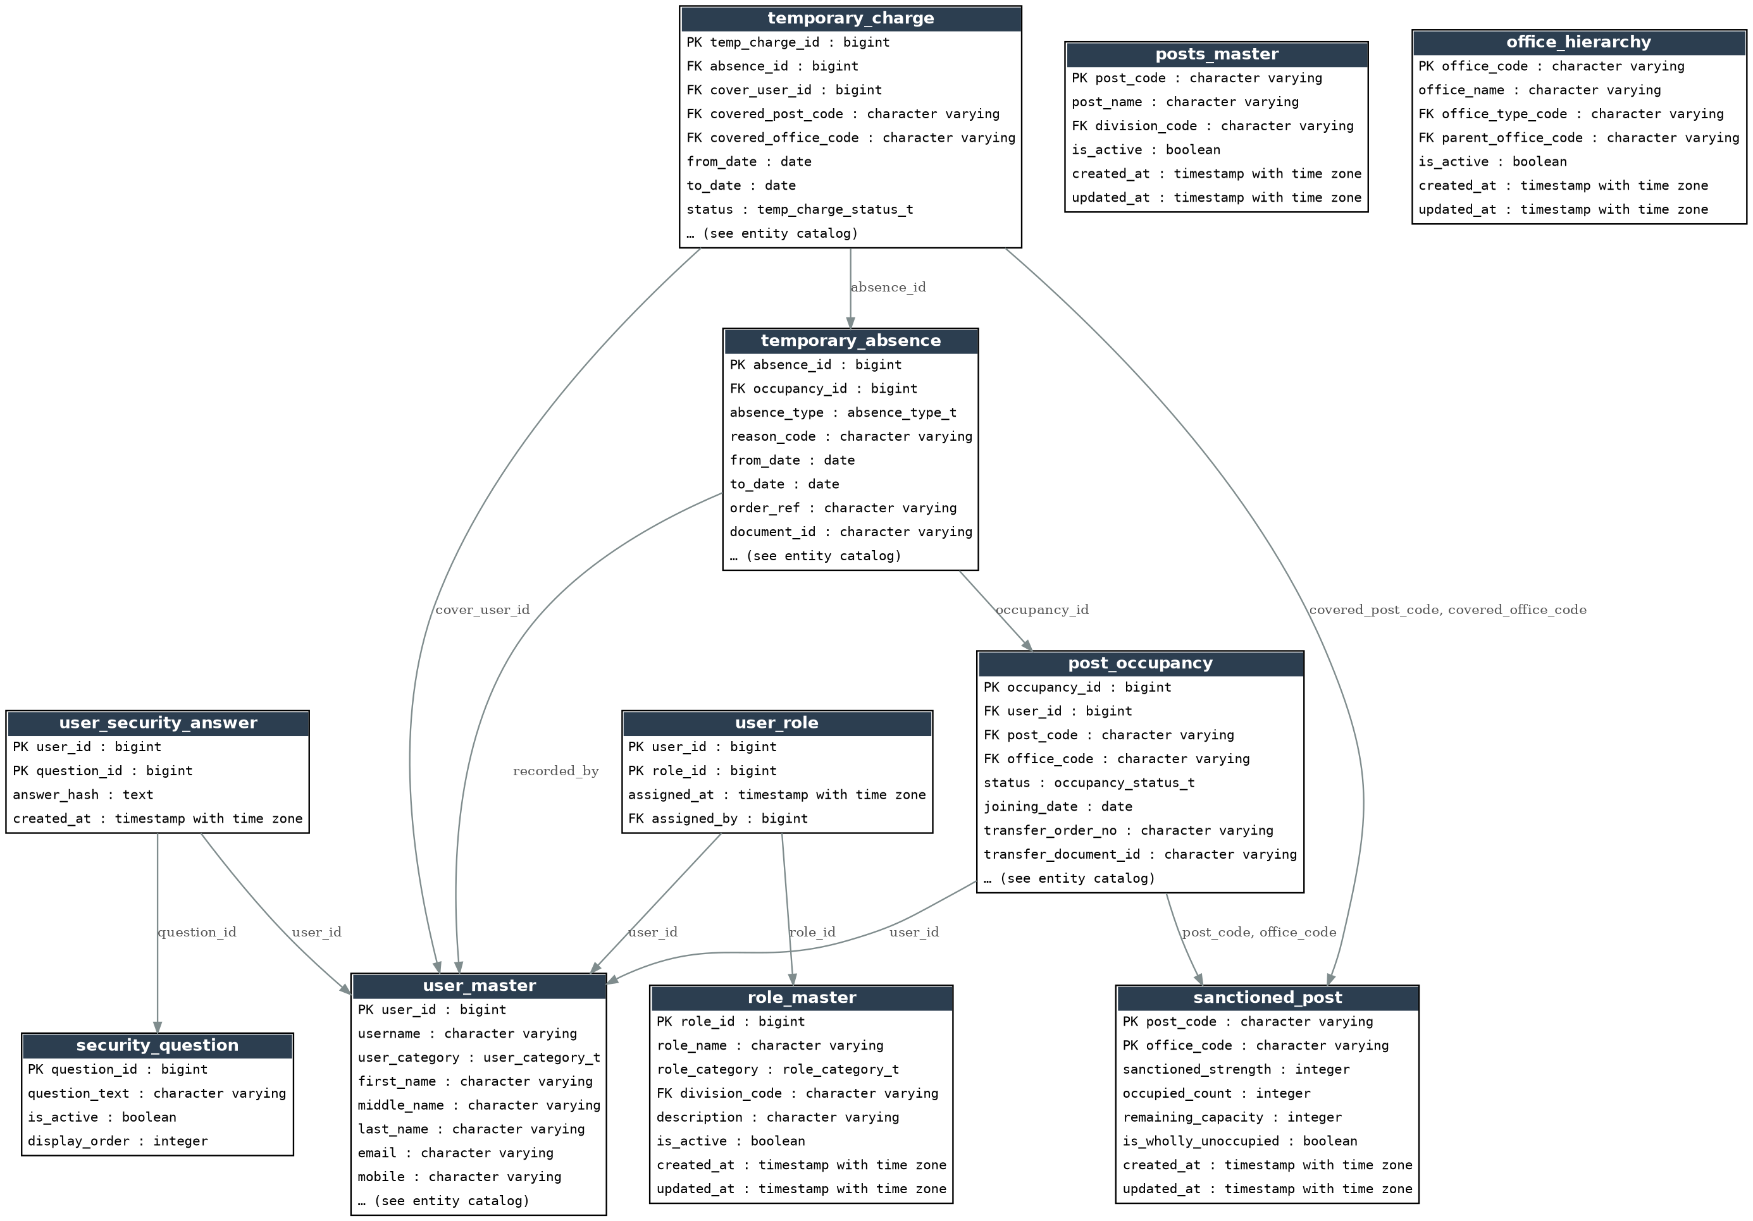
Figure 3 — Users, Roles, Security Q&A, Post Occupancy, Temporary Absence / Charge

2.4 RBAC & Runtime
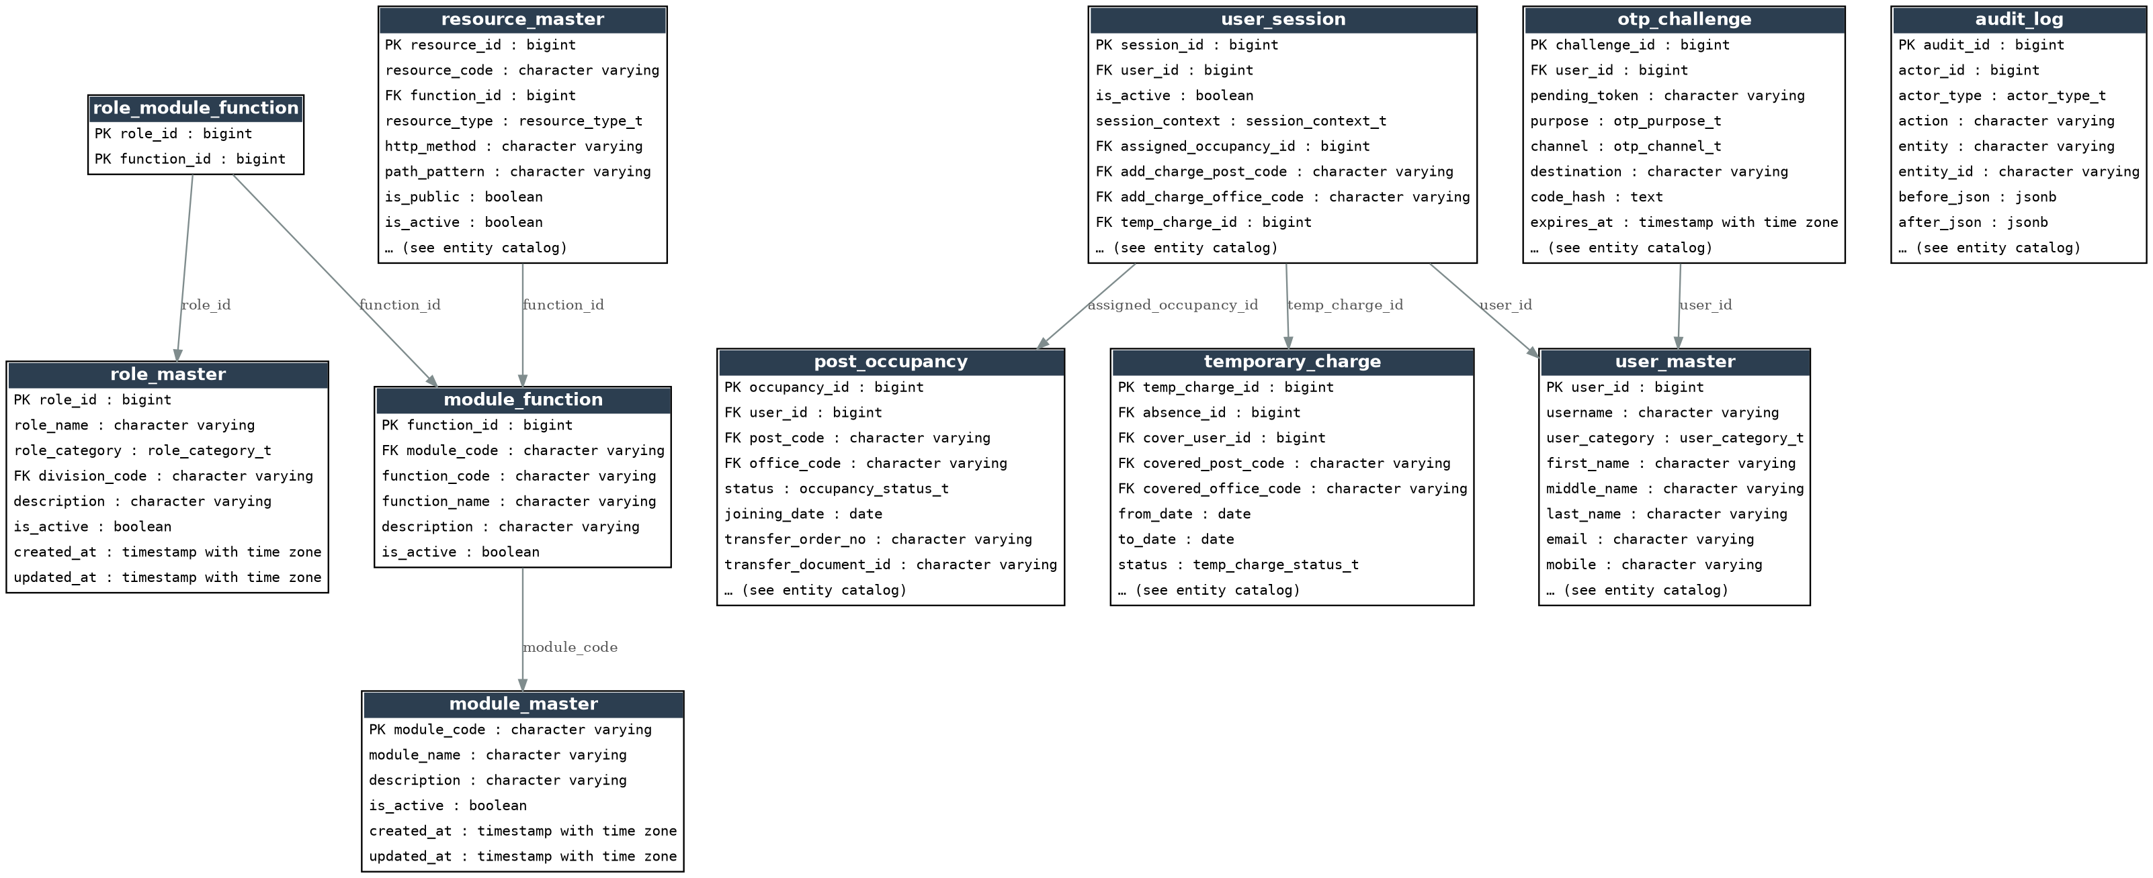
Figure 4 — Modules, Functions, Resources, Sessions, OTP, Audit

3. Enumerated Types
Defined once in 02_types.sql and reused across the tables below (PostgreSQL ENUM types).
Type | Values
user_category_t | CITIZEN, DSR_OFFICER, OTHER_DEPARTMENT
role_category_t | CITIZEN, DSR, OTHER_DEPARTMENT
account_status_t | ACTIVE, SUSPENDED, DEACTIVATED
occupancy_status_t | ACTIVE, RESERVED, ENDED
absence_type_t | LEAVE, OOD, OTHER
absence_status_t | APPROVED, CANCELLED, ENDED
temp_charge_status_t | ACTIVE, CANCELLED, ENDED
session_context_t | ASSIGNED, ADDITIONAL_CHARGE, TEMPORARY_CHARGE
otp_purpose_t | LOGIN, REG_EMAIL, REG_MOBILE, RESET_PIN, NEW_MOBILE
otp_channel_t | SMS, EMAIL
resource_type_t | API, URL
actor_type_t | USER, APPLICATION_ADMIN, SYSTEM

4. Entity Catalog
24 tables, grouped as in Section 2. Every entity ends with a Sample Records section.

4.1 Organisation & Establishment
Related requirements: FR-UM-046, FR-UM-049, FR-UM-059, FR-UM-077, FR-UM-078

um.division_master
Enumerated DSR organisational divisions (FR-UM-077)
Column | Type | Key | Null | References | Description
division_code | varchar | PK | No
division_name | varchar |  | No
display_order | integer |  | No
is_active | boolean |  | No
created_at | timestamptz |  | No
updated_at | timestamptz |  | No

Sample Records
Attribute | Sample record 1 | Sample record 2 | Sample record 3 | Sample record 4
division_code | DIV-ADMIN | DIV-COMPUTERS | DIV-CVC | DIV-ENFORCEMENT
division_name | Admin, Law & Computers | Computers | DIGR CVC | Enforcement
display_order | 3 | 5 | 8 | 6
is_active | True | True | True | True
created_at | 2026-09-05 06:07 | 2026-09-05 06:07 | 2026-09-05 06:07 | 2026-09-05 06:07
updated_at | 2026-09-05 06:07 | 2026-09-05 06:07 | 2026-09-05 06:07 | 2026-09-05 06:07

um.office_type
Secretariat | Head Office | District Registrar Office | Sub-Registrar Office
Column | Type | Key | Null | References | Description
office_type_code | varchar | PK | No
display_name | varchar |  | No
is_active | boolean |  | No

Sample Records
Attribute | Sample record 1 | Sample record 2 | Sample record 3 | Sample record 4
office_type_code | DIST_REGISTRAR_OFFICE | HEAD_OFFICE | SECRETARIAT | SUB_REGISTRAR_OFFICE
display_name | District Registrar Office | Head Office | Secretariat | Sub-Registrar Office
is_active | True | True | True | True

um.office_hierarchy
DSR office tree: MS Building → IGR → DRO → SRO (FR-UM-059)
Column | Type | Key | Null | References | Description
office_code | varchar | PK | No
office_name | varchar |  | No
office_type_code | varchar | FK | No | office_type.office_type_code
parent_office_code | varchar | FK | Yes | office_hierarchy.office_code
is_active | boolean |  | No
created_at | timestamptz |  | No
updated_at | timestamptz |  | No

Sample Records
Attribute | Sample record 1 | Sample record 2 | Sample record 3 | Sample record 4
office_code | OFF-DRO-BLR | OFF-DRO-MYS | OFF-IGR | OFF-MS-BLDG
office_name | DRO Bengaluru | DRO Mysuru | IGR Office (Head Office) | MS Building
office_type_code | DIST_REGISTRAR_OFFICE | DIST_REGISTRAR_OFFICE | HEAD_OFFICE | SECRETARIAT
parent_office_code | OFF-IGR | OFF-IGR | OFF-MS-BLDG | —
is_active | True | True | True | True
created_at | 2026-09-05 06:07 | 2026-09-05 06:07 | 2026-09-05 06:07 | 2026-09-05 06:07
updated_at | 2026-09-05 06:07 | 2026-09-05 06:07 | 2026-09-05 06:07 | 2026-09-05 06:07

um.posts_master
DSR establishment posts — distinct from Role Master (FR-UM-046, FR-UM-049)
Column | Type | Key | Null | References | Description
post_code | varchar | PK | No
post_name | varchar |  | No
division_code | varchar | FK | No | division_master.division_code
is_active | boolean |  | No
created_at | timestamptz |  | No
updated_at | timestamptz |  | No

Sample Records
Attribute | Sample record 1 | Sample record 2 | Sample record 3 | Sample record 4
post_code | POST-ACCT-SUP | POST-ACS-SEC | POST-AIGR-ADMIN | POST-AIGR-AUDIT
post_name | Accountant Superintendent (Admin) | Additional Chief Secretary / Principal Secretary / Secretary | AIGR (Admin) | AIGR (Audit)
division_code | DIV-ADMIN | DIV-SECRETARIAT | DIV-ADMIN | DIV-INT-AUDIT
is_active | True | True | True | True
created_at | 2026-09-05 06:07 | 2026-09-05 06:07 | 2026-09-05 06:07 | 2026-09-05 06:07
updated_at | 2026-09-05 06:07 | 2026-09-05 06:07 | 2026-09-05 06:07 | 2026-09-05 06:07

um.officer_hierarchy_node
Reporting tree of Posts (not people) — FR-UM-043
Column | Type | Key | Null | References | Description
node_id | bigint | PK | No
post_code | varchar | FK | No | posts_master.post_code
parent_node_id | bigint | FK | Yes | officer_hierarchy_node.node_id
division_code | varchar | FK | Yes | division_master.division_code | Division / Branch attribute of the hierarchy node (FR-UM-043, Section 6.5.7 attributes table)
display_order | integer |  | No
effective_from | date |  | Yes |  | Optional validity window start of the hierarchy link (Section 6.5.7 attributes table)
effective_to | date |  | Yes |  | Optional validity window end of the hierarchy link (Section 6.5.7 attributes table)
is_active | boolean |  | No
created_at | timestamptz |  | No
updated_at | timestamptz |  | No

Sample Records
Attribute | Sample record 1 | Sample record 2 | Sample record 3 | Sample record 4
node_id | 1 | 2 | 3 | 4
post_code | POST-ACS-SEC | POST-IGR | POST-DIGR-ADMIN | POST-AIGR-ADMIN
parent_node_id | — | 1 | 2 | 3
division_code | DIV-SECRETARIAT | DIV-TOP-MGMT | DIV-ADMIN | DIV-ADMIN
display_order | 0 | 0 | 0 | 0
effective_from | — | — | — | —
effective_to | — | — | — | —
is_active | True | True | True | True
created_at | 2026-09-05 06:07 | 2026-09-05 06:07 | 2026-09-05 06:07 | 2026-09-05 06:07
updated_at | 2026-09-05 06:07 | 2026-09-05 06:07 | 2026-09-05 06:07 | 2026-09-05 06:07

um.post_office_type_allowed
Which Post codes may be sanctioned at which Office Types (FR-UM-078)
Column | Type | Key | Null | References | Description
post_code | varchar | PK | No | posts_master.post_code
office_type_code | varchar | PK | No | office_type.office_type_code

Sample Records
Attribute | Sample record 1 | Sample record 2 | Sample record 3 | Sample record 4
post_code | POST-ACCT-SUP | POST-ACS-SEC | POST-AIGR-ADMIN | POST-AIGR-AUDIT
office_type_code | HEAD_OFFICE | SECRETARIAT | HEAD_OFFICE | HEAD_OFFICE

um.post_role_map
Unmapped post cannot be sanctioned or assigned (FR-UM-047)
Column | Type | Key | Null | References | Description
post_code | varchar | PK | No | posts_master.post_code
role_id | bigint | PK | No | role_master.role_id

Sample Records
Attribute | Sample record 1 | Sample record 2 | Sample record 3 | Sample record 4
post_code | POST-ACCT-SUP | POST-ACS-SEC | POST-AIGR-ADMIN | POST-AIGR-AUDIT
role_id | 23 | 17 | 20 | 49

um.sanctioned_post
Approved headcount per Post at Office; occupied_count job-maintained (FR-UM-068)
Column | Type | Key | Null | References | Description
post_code | varchar | PK | No | posts_master.post_code
office_code | varchar | PK | No | office_hierarchy.office_code
sanctioned_strength | integer |  | No
occupied_count | integer |  | No |  | Active + Reserved occupancies; Temporary Absence does NOT reduce this (FR-UM-081)
remaining_capacity | integer |  | Yes |  | Persisted (generated), floored at 0 — FR-UM-066(a), FR-UM-068(3): GREATEST(sanctioned_strength - occupied_count, 0). During an FR-UM-067 handover, occupied_count may transiently exceed sanctioned_strength by 1 (outgoing officer still active + incoming reserved Transfer In); remaining_capacity reads 0, not negative, in that window.
is_wholly_unoccupied | boolean |  | Yes |  | Persisted (generated) — FR-UM-066(b), FR-UM-068(3): true only when occupied_count = 0
created_at | timestamptz |  | No
updated_at | timestamptz |  | No

Sample Records
Attribute | Sample record 1 | Sample record 2 | Sample record 3 | Sample record 4
post_code | POST-ACS-SEC | POST-DEO | POST-DIGR-ADMIN | POST-DIGR-ENF
office_code | OFF-MS-BLDG | OFF-SRO-YESH | OFF-IGR | OFF-IGR
sanctioned_strength | 1 | 2 | 1 | 1
occupied_count | 1 | 0 | 1 | 0
remaining_capacity | 0 | 2 | 0 | 1
is_wholly_unoccupied | False | True | False | True
created_at | 2026-09-05 06:07 | 2026-09-05 06:07 | 2026-09-05 06:07 | 2026-09-05 06:07
updated_at | 2026-09-05 06:07 | 2026-09-05 06:07 | 2026-09-05 06:07 | 2026-09-05 06:07

4.2 Identity & Security
Related requirements: FR-UM-004, FR-UM-016, FR-UM-055, FR-UM-062, FR-UM-064

um.user_master
Single user store; username unique (Citizen preferred / KGID); email & mobile NOT unique (FR-UM-004, FR-UM-062)
Column | Type | Key | Null | References | Description
user_id | bigint | PK | No
username | varchar |  | No |  | Only unique login identifier across all categories — no password attribute (FR-UM-009)
user_category | user_category_t |  | No
first_name | varchar |  | No
middle_name | varchar |  | Yes
last_name | varchar |  | Yes |  | Nullable — single-name citizens are common; only first_name is mandatory
email | varchar |  | No
mobile | varchar |  | No
parent_department | varchar |  | Yes
designation | varchar |  | Yes
account_end_date | date |  | Yes
status | account_status_t |  | No
status_reason | varchar |  | Yes
lockout_until | timestamptz |  | Yes
reset_lockout_until | timestamptz |  | Yes
biometric_ref | varchar |  | Yes
photo_ref | varchar |  | Yes
id_proof_ref | varchar |  | Yes
authorisation_letter_ref | varchar |  | Yes
created_at | timestamptz |  | No
updated_at | timestamptz |  | No
created_by | bigint |  | Yes

Sample Records
Attribute | Sample record 1 | Sample record 2 | Sample record 3 | Sample record 4
user_id | 1 | 2 | 3 | 4
username | ravi.citizen1 | KGID10234501 | KGID10234599 | KGID10234610
user_category | CITIZEN | DSR_OFFICER | DSR_OFFICER | DSR_OFFICER
first_name | Ravi | Anitha | Suresh | Manjunath
middle_name | — | — | — | —
last_name | Kumar | Rao | Patil | —
email | ravi.kumar@example.com | anitha.rao@karnataka.gov.in | suresh.patil@karnataka.gov.in | manjunath@karnataka.gov.in
mobile | 9900011111 | 9900022222 | 9900033333 | 9900044444
parent_department | — | — | — | —
designation | — | — | — | —
account_end_date | — | — | — | —
status | ACTIVE | ACTIVE | ACTIVE | ACTIVE
status_reason | — | — | — | —
lockout_until | — | — | — | —
reset_lockout_until | — | — | — | —
biometric_ref | — | — | — | —
photo_ref | — | — | — | —
id_proof_ref | — | — | — | —
authorisation_letter_ref | — | — | — | —
created_at | 2026-06-07 06:07 | 2025-08-01 06:07 | 2025-01-13 06:07 | 2026-08-06 06:07
updated_at | 2026-09-05 06:07 | 2026-09-05 06:07 | 2026-09-05 06:07 | 2026-09-05 06:07
created_by | — | — | — | —

um.role_master
Single role catalogue Citizen | DSR | Other Department (FR-UM-016); Application Admin is NOT a seed row (FR-UM-051)
Column | Type | Key | Null | References | Description
role_id | bigint | PK | No
role_name | varchar |  | No
role_category | role_category_t |  | No
division_code | varchar | FK | Yes | division_master.division_code
description | varchar |  | Yes
is_active | boolean |  | No
created_at | timestamptz |  | No
updated_at | timestamptz |  | No

Sample Records
Attribute | Sample record 1 | Sample record 2 | Sample record 3 | Sample record 4
role_id | 1 | 2 | 3 | 4
role_name | Citizen | Marriage Applicant | Document Registration Applicant | Certified Copy / EC Applicant
role_category | CITIZEN | CITIZEN | CITIZEN | CITIZEN
division_code | — | — | — | —
description | Default role assigned on instant self-registration; access to citizen portal services | Apply for Hindu Marriage / Special Marriage registration and related citizen actions | Initiate and track document registration applications | Apply for Encumbrance Certificate (EC) and certified copy of registered documents
is_active | True | True | True | True
created_at | 2026-09-05 06:07 | 2026-09-05 06:07 | 2026-09-05 06:07 | 2026-09-05 06:07
updated_at | 2026-09-05 06:07 | 2026-09-05 06:07 | 2026-09-05 06:07 | 2026-09-05 06:07

um.user_role
Direct roles for Citizen (1..*) and Other Department (exactly 1); DSR uses Post–Role only
Column | Type | Key | Null | References | Description
user_id | bigint | PK | No | user_master.user_id
role_id | bigint | PK | No | role_master.role_id
assigned_at | timestamptz |  | No
assigned_by | bigint | FK | Yes | user_master.user_id

Sample Records
Attribute | Sample record 1 | Sample record 2
user_id | 1 | 6
role_id | 1 | 7
assigned_at | 2026-09-05 06:07 | 2026-09-05 06:07
assigned_by | — | —

um.security_question
Predefined list a Citizen picks 5 of at registration (FR-UM-055); 3 asked at random on lost-mobile reset (FR-UM-056)
Column | Type | Key | Null | References | Description
question_id | bigint | PK | No
question_text | varchar |  | No
is_active | boolean |  | No
display_order | integer |  | No

Sample Records
Attribute | Sample record 1 | Sample record 2 | Sample record 3 | Sample record 4
question_id | 1 | 2 | 3 | 4
question_text | What is your mother's maiden name? | What was the name of your first school? | What is your favourite teacher's name? | What is the name of the town where you were born?
is_active | True | True | True | True
display_order | 1 | 2 | 3 | 4

um.user_security_answer
Exactly five distinct hashed answers per Citizen; never displayed (FR-UM-055)
Column | Type | Key | Null | References | Description
user_id | bigint | PK | No | user_master.user_id
question_id | bigint | PK | No | security_question.question_id
answer_hash | text |  | No
created_at | timestamptz |  | No

Sample Records
Attribute | Sample record 1 | Sample record 2 | Sample record 3 | Sample record 4
user_id | 1 | 1 | 1 | 1
question_id | 1 | 2 | 3 | 4
answer_hash | cc4257069c8a0b0d7467ac21fd1b9264518639c9e5fbafc1538a0c53d74cf0b1 | 634beb50ca12247a3ac1d96743f869cc7c502406913aa1e7f6953378fc5afd74 | 74336f792c1f26a17e5bd47eccedb363888945e093ec6a8506d012a24b8b37a5 | 7d95f89be7bc193cad19f7671cca46fd1a636b0cf449491d963b82140bc0dbf2
created_at | 2026-09-05 06:07 | 2026-09-05 06:07 | 2026-09-05 06:07 | 2026-09-05 06:07

um.official_email_domain
Permitted official email domain allow-list for DSR / Other Department creation (FR-UM-064); empty = no domain restriction enforced
Column | Type | Key | Null | References | Description
domain | varchar | PK | No
is_active | boolean |  | No

Sample Records
No sample rows loaded — empty by default (optional configuration table).

4.3 Occupancy, Absence & Temporary Charge
Related requirements: FR-UM-030, FR-UM-045, FR-UM-057–FR-UM-061, FR-UM-066–FR-UM-068, FR-UM-079–FR-UM-084

um.post_occupancy
DSR user ↔ sanctioned Post+Office; Transfer In / Relieving / deputation as attributes
Column | Type | Key | Null | References | Description
occupancy_id | bigint | PK | No
user_id | bigint | FK | No | user_master.user_id
post_code | varchar | FK | No | sanctioned_post.post_code, sanctioned_post.office_code
office_code | varchar | FK | No | sanctioned_post.post_code, sanctioned_post.office_code
status | occupancy_status_t |  | No
joining_date | date |  | Yes
transfer_order_no | varchar |  | Yes
transfer_document_id | varchar |  | Yes
relieving_date | date |  | Yes
relieving_order_no | varchar |  | Yes
relieving_document_id | varchar |  | Yes
end_date | date |  | Yes
deputation_reason | varchar |  | Yes
reserved_flag | boolean |  | No |  | FR-UM-067 reserved Transfer In — counts toward Occupied immediately
created_by | bigint | FK | Yes | user_master.user_id
created_at | timestamptz |  | No
updated_at | timestamptz |  | No
ended_at | timestamptz |  | Yes

Sample Records
Attribute | Sample record 1 | Sample record 2 | Sample record 3 | Sample record 4
occupancy_id | 1 | 2 | 3 | 4
user_id | 2 | 3 | 4 | 5
post_code | POST-SR | POST-DRO | POST-DRO | POST-SR
office_code | OFF-SRO-YESH | OFF-DRO-BLR | OFF-DRO-BLR | OFF-SRO-JAY
status | ACTIVE | ACTIVE | RESERVED | ACTIVE
joining_date | — | — | 2026-09-01 | —
transfer_order_no | — | — | TO/2026/1123 | —
transfer_document_id | — | — | — | —
relieving_date | — | 2026-08-31 | — | —
relieving_order_no | — | RO/2026/0891 | — | —
relieving_document_id | — | — | — | —
end_date | — | — | — | —
deputation_reason | — | — | — | —
reserved_flag | False | False | True | False
created_by | 2 | 3 | 4 | 5
created_at | 2025-08-01 06:07 | 2025-01-13 06:07 | 2026-08-31 06:07 | 2025-04-23 06:07
updated_at | 2026-09-05 06:07 | 2026-09-05 06:07 | 2026-09-05 06:07 | 2026-09-05 06:07
ended_at | — | — | — | —

um.temporary_absence
Leave / OOD / Other on active occupancy; does not free capacity (FR-UM-079, FR-UM-081)
Column | Type | Key | Null | References | Description
absence_id | bigint | PK | No
occupancy_id | bigint | FK | No | post_occupancy.occupancy_id
absence_type | absence_type_t |  | No
reason_code | varchar |  | No
from_date | date |  | No
to_date | date |  | No
order_ref | varchar |  | Yes
document_id | varchar |  | Yes
status | absence_status_t |  | No
recorded_by | bigint | FK | No | user_master.user_id
cancelled_by | bigint | FK | Yes | user_master.user_id
cancelled_at | timestamptz |  | Yes
created_at | timestamptz |  | No
updated_at | timestamptz |  | No

Sample Records
Attribute | Sample record 1
absence_id | 1
occupancy_id | 1
absence_type | LEAVE
reason_code | PERSONAL
from_date | 2026-09-01
to_date | 2026-09-05
order_ref | —
document_id | —
status | APPROVED
recorded_by | 3
cancelled_by | —
cancelled_at | —
created_at | 2026-09-02 06:07
updated_at | 2026-09-05 06:07

um.temporary_charge
Superior-assigned cover of absent Post+Office; distinct from FR-UM-053 (FR-UM-082)
Column | Type | Key | Null | References | Description
temp_charge_id | bigint | PK | No
absence_id | bigint | FK | No | temporary_absence.absence_id
cover_user_id | bigint | FK | No | user_master.user_id
covered_post_code | varchar | FK | No | sanctioned_post.post_code, sanctioned_post.office_code
covered_office_code | varchar | FK | No | sanctioned_post.post_code, sanctioned_post.office_code
from_date | date |  | No
to_date | date |  | No
status | temp_charge_status_t |  | No
assigned_by | bigint | FK | No | user_master.user_id
order_ref | varchar |  | Yes
document_id | varchar |  | Yes
created_at | timestamptz |  | No
cancelled_at | timestamptz |  | Yes

Sample Records
Attribute | Sample record 1
temp_charge_id | 1
absence_id | 1
cover_user_id | 5
covered_post_code | POST-SR
covered_office_code | OFF-SRO-YESH
from_date | 2026-09-01
to_date | 2026-09-05
status | ACTIVE
assigned_by | 3
order_ref | —
document_id | —
created_at | 2026-09-02 06:07
cancelled_at | —

4.4 RBAC — Modules, Functions, Resources
Related requirements: FR-UM-036–FR-UM-041, FR-UM-047, FR-UM-050

um.module_master
Catalogue of application modules — Registration of Documents, Marriage Registration, etc. (Section 6.5.6)
Column | Type | Key | Null | References | Description
module_code | varchar | PK | No
module_name | varchar |  | No
description | varchar |  | Yes
is_active | boolean |  | No
created_at | timestamptz |  | No
updated_at | timestamptz |  | No

Sample Records
Attribute | Sample record 1 | Sample record 2 | Sample record 3 | Sample record 4
module_code | MOD-CC | MOD-DOC-REG | MOD-EC | MOD-FIRM
module_name | Certified Copy | Registration of Documents | Encumbrance Search | Firm / Society Registration
description | Application and issue of certified copies of registered documents | Registration of documents | Search and issue of Encumbrance Certificate (EC) | Firm and society related registration services
is_active | True | True | True | True
created_at | 2026-09-05 06:07 | 2026-09-05 06:07 | 2026-09-05 06:07 | 2026-09-05 06:07
updated_at | 2026-09-05 06:07 | 2026-09-05 06:07 | 2026-09-05 06:07 | 2026-09-05 06:07

um.module_function
VIEW, ADD, EDIT, APPROVE, SIGN, PRINT, DOWNLOAD, FN-UM-ADMIN, … (FR-UM-039)
Column | Type | Key | Null | References | Description
function_id | bigint | PK | No
module_code | varchar | FK | No | module_master.module_code
function_code | varchar |  | No |  | Globally unique code referenced by Resource Master and Role–Module–Function mapping, e.g. FN-DOC-VIEW
function_name | varchar |  | No |  | Short privilege verb shown in UI, e.g. VIEW, ADD, EDIT, APPROVE, SIGN, PRINT, DOWNLOAD
description | varchar |  | Yes
is_active | boolean |  | No

Sample Records
Attribute | Sample record 1 | Sample record 2 | Sample record 3 | Sample record 4
function_id | 1 | 2 | 3 | 4
module_code | MOD-DOC-REG | MOD-DOC-REG | MOD-DOC-REG | MOD-DOC-REG
function_code | FN-DOC-VIEW | FN-DOC-ADD | FN-DOC-EDIT | FN-DOC-APPROVE
function_name | VIEW | ADD | EDIT | APPROVE
description | View document registration applications / records | Create / initiate document registration | Edit draft / in-progress applications | Approve application for registration
is_active | True | True | True | True

um.resource_master
API / URL linked to Module Function; deny-by-default unless is_public (FR-UM-040, FR-UM-041)
Column | Type | Key | Null | References | Description
resource_id | bigint | PK | No
resource_code | varchar |  | No |  | Admin-defined unique identifier, e.g. RES-DOC-GET (Section 6.5.6 Resource Master attributes)
function_id | bigint | FK | Yes | module_function.function_id | Required for non-public resources; NULL only allowed when is_public = true (FR-UM-041)
resource_type | resource_type_t |  | No
http_method | varchar |  | Yes
path_pattern | varchar |  | No
is_public | boolean |  | No
is_active | boolean |  | No
created_at | timestamptz |  | No
updated_at | timestamptz |  | No

Sample Records
Attribute | Sample record 1 | Sample record 2 | Sample record 3 | Sample record 4
resource_id | 1 | 2 | 3 | 4
resource_code | RES-UI-DOC-VIEW | RES-DOC-LIST | RES-DOC-GET | RES-UI-DOC-CREATE
function_id | 1 | 1 | 1 | 2
resource_type | URL | API | API | URL
http_method | GET | GET | GET | GET
path_pattern | /app/documents/view | /api/v1/documents | /api/v1/documents/{id} | /app/documents/create
is_public | False | False | False | False
is_active | True | True | True | True
created_at | 2026-09-05 06:07 | 2026-09-05 06:07 | 2026-09-05 06:07 | 2026-09-05 06:07
updated_at | 2026-09-05 06:07 | 2026-09-05 06:07 | 2026-09-05 06:07 | 2026-09-05 06:07

um.role_module_function
Role name must match Role Master exactly (FR-UM-050); Application Admin outside this map (FR-UM-051)
Column | Type | Key | Null | References | Description
role_id | bigint | PK | No | role_master.role_id
function_id | bigint | PK | No | module_function.function_id

Sample Records
Attribute | Sample record 1 | Sample record 2 | Sample record 3 | Sample record 4
role_id | 1 | 1 | 1 | 1
function_id | 1 | 2 | 10 | 12

4.5 Runtime & Audit
Related requirements: FR-UM-069–FR-UM-076, FR-UM-010, FR-UM-022, FR-UM-084

um.user_session
Idle 15 min (FR-UM-074); absolute 8 h (FR-UM-075); last-login-wins (FR-UM-076)
Column | Type | Key | Null | References | Description
session_id | bigint | PK | No
user_id | bigint | FK | No | user_master.user_id
is_active | boolean |  | No
session_context | session_context_t |  | Yes
assigned_occupancy_id | bigint | FK | Yes | post_occupancy.occupancy_id
add_charge_post_code | varchar | FK | Yes | posts_master.post_code
add_charge_office_code | varchar | FK | Yes | office_hierarchy.office_code
temp_charge_id | bigint | FK | Yes | temporary_charge.temp_charge_id
login_at | timestamptz |  | No
last_activity_at | timestamptz |  | No
expires_at | timestamptz |  | No
ended_at | timestamptz |  | Yes
end_reason | varchar |  | Yes

Sample Records
Attribute | Sample record 1 | Sample record 2
session_id | 1 | 2
user_id | 1 | 2
is_active | True | True
session_context | — | ASSIGNED
assigned_occupancy_id | — | 1
add_charge_post_code | — | —
add_charge_office_code | — | —
temp_charge_id | — | —
login_at | 2026-09-05 05:57 | 2026-09-05 05:42
last_activity_at | 2026-09-05 06:06 | 2026-09-05 06:05
expires_at | 2026-09-05 13:57 | 2026-09-05 13:42
ended_at | — | —
end_reason | — | —

um.otp_challenge
OTP/PIN challenges — login SMS only (FR-UM-010); policy FR-UM-069–FR-UM-072
Column | Type | Key | Null | References | Description
challenge_id | bigint | PK | No
user_id | bigint | FK | Yes | user_master.user_id
pending_token | varchar |  | Yes
purpose | otp_purpose_t |  | No
channel | otp_channel_t |  | No
destination | varchar |  | No
code_hash | text |  | No
expires_at | timestamptz |  | No
attempt_count | integer |  | No
resend_count | integer |  | No
invalidated | boolean |  | No
consumed_at | timestamptz |  | Yes
created_at | timestamptz |  | No

Sample Records
Attribute | Sample record 1 | Sample record 2
challenge_id | 1 | 2
user_id | 2 | 1
pending_token | — | —
purpose | LOGIN | REG_MOBILE
channel | SMS | SMS
destination | 9900022222 | 9900011111
code_hash | 8d969eef6ecad3c29a3a629280e686cf0c3f5d5a86aff3ca12020c923adc6c92 | 481f6cc0511143ccdd7e2d1b1b94faf0a700a8b49cd13922a70b5ae28acaa8c5
expires_at | 2026-09-05 05:47 | 2026-06-12 06:07
attempt_count | 1 | 1
resend_count | 0 | 0
invalidated | False | False
consumed_at | 2026-09-05 05:42 | 2026-06-07 06:07
created_at | 2026-09-05 05:42 | 2026-06-07 06:07

um.audit_log
Append-only; retain ≥ 7 years; includes temporary absence / charge events (FR-UM-084)
Column | Type | Key | Null | References | Description
audit_id | bigint | PK | No
actor_id | bigint |  | Yes
actor_type | actor_type_t |  | No
action | varchar |  | No
entity | varchar |  | No
entity_id | varchar |  | Yes
before_json | jsonb |  | Yes
after_json | jsonb |  | Yes
reason | varchar |  | Yes
artefact_id | varchar |  | Yes
occurred_at | timestamptz |  | No
ip_address | inet |  | Yes
user_agent | varchar |  | Yes

Sample Records
Attribute | Sample record 1 | Sample record 2 | Sample record 3 | Sample record 4
audit_id | 1 | 2 | 3 | 4
actor_id | 2 | 2 | 1 | —
actor_type | USER | USER | USER | SYSTEM
action | LOGIN_SUCCESS | ADD_CHARGE_TAKEN | CITIZEN_LOST_MOBILE_RESET | OCCUPANCY_REFRESH
entity | SESSION | SESSION | USER_CONTACT | JOB
entity_id | 2 | 2 | 1 | 2026-09-05
before_json | — | — | — | —
after_json | {'result': 'SUCCESS', 'channel': 'SMS'} | {'office_code': 'OFF-SRO-YESH', 'assigned_post_code': 'POST-SR', 'additional_charge_post_code': 'POST-DEO'} | — | {'as_of': '2026-09-05', 'ended_charges': 0, 'ended_absences': 0, 'ended_occupancies': 1}
reason | — | — | Lost registered mobile — 3 of 5 security questions + email PIN verified | FR-UM-068 / FR-UM-084 midnight refresh
artefact_id | — | — | — | —
occurred_at | 2026-09-05 05:42 | 2026-09-05 05:52 | 2026-07-27 06:07 | 2026-09-05 00:07
ip_address | — | — | — | —
user_agent | — | — | — | —

5. Views (Reporting & Runtime)
17 views in 09_views.sql — runtime-decision helpers plus full coverage of the Section 8 (Reporting Requirements) list.
View | Purpose
um.v_absence_charge_report | Temporary Absence and Temporary Charge report (Section 8; FR-UM-084).
um.v_active_temporary_charge | Temporary-charge rows offered at login post selection (FR-UM-052, FR-UM-083).
um.v_additional_charge_report | Additional charge taken / cleared report (Section 8 bullet 7; FR-UM-053).
um.v_contact_change_recovery_report | Citizen lost-mobile reset, admin mobile change, and email change report (Section 8 bullet 6).
um.v_dsr_login_post_options | Union of active assigned occupancies and active temporary charges for FR-UM-052 post selection.
um.v_effective_absence | Approved absences covering the current IST calendar day — blocks login (FR-UM-080).
um.v_login_audit_report | Login attempt audit — successful and failed (Section 8 bullet 2).
um.v_login_blocked_by_absence | Usernames currently denied login due to effective absence.
um.v_occupancy_refresh_report | Occupancy-refresh midnight job run report (Section 8 bullet 9; FR-UM-068).
um.v_office_descendants | Recursive office-span lookup — root office plus all descendants (FR-UM-059).
um.v_officer_posting_history | Officer posting and service history report (Section 8 bullet 11).
um.v_role_module_function | Role → Module → Function report (Section 8 bullet 5).
um.v_sanctioned_post_capacity | Available-capacity vs wholly-unoccupied vacancy tests per Post+Office (FR-UM-066).
um.v_session_role_claims | Resolves a session's active role claims from assigned post / additional charge / temporary charge (FR-UM-038).
um.v_transfer_history_report | Transfer Out / Transfer In history report (Section 8 bullet 10).
um.v_user_effective_roles | Role and permission assignments across all users — direct and post-derived (Section 8 bullet 3).
um.v_user_status_report | All active, inactive, and suspended users (Section 8 bullet 1).

6. Traceability & Verification
This ERD and its companion DDL scripts (E:\...\Finalized BRD\User Management\DDL) were verified together:
- The full script set (00 through 13) was executed end-to-end against a clean PostgreSQL 16 database with psql -v ON_ERROR_STOP=1 — zero errors.
- 12_seed_masters.sql loads the BRD's own seed/example rows: 8 divisions, 4 office types, 7 offices, 40 posts, 41 post–office-type-allowed rows, 40 post–role mappings, 40 officer-hierarchy nodes, 13 illustrative sanctioned-post rows, 56 roles (6 Citizen + 10 Other Department + 40 DSR), 8 modules, 14 module functions, 14 resources, 19 Role–Module–Function example rows, and 8 predefined security questions.
- 13_sample_transactional_data.sql (illustrative, non-production) exercises every remaining table — users, occupancy (including a Transfer-In handover reservation), Temporary Absence + Temporary Charge, sessions, OTP challenges, and audit log — and every one of the 8 new reporting views was queried successfully against the result.
- Every Sample Records table in Section 4 is a direct dump of the rows actually present after that run — nothing in this document was hand-typed independently of the schema.

